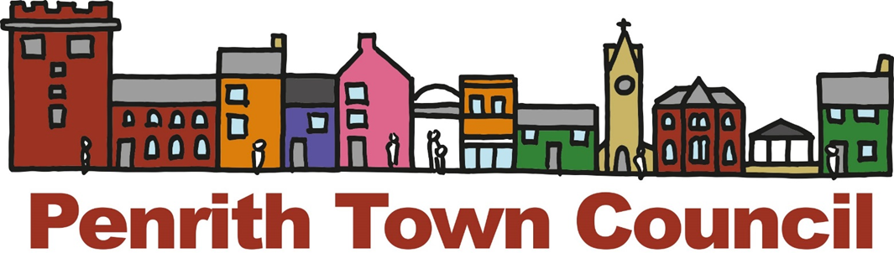
Unit 1, Church House, 19-24 Friargate, Penrith, Cumbria, CA11 7XR
Tel: 01768 899 773 Email: office@penrithtowncouncil.gov.uk

ANNUAL TOWN MEETING OF PENRITH

Minutes of the Meeting held on

Monday 22 April 2024

ATM2324/01 Welcome
At 6.00pm Councillor Doug Lawson, the Chair of Penrith Town Council and Mayor of Penrith welcomed everyone present to the meeting.

ATM2324/02 Minutes
The meeting was asked to receive the minutes from the Annual Town Meeting held on Monday 24 April 2023.
RESOLVED THAT:
The minutes of the Annual Town Meeting held on 24 April 2023 be received and signed by the Mayor.

ATM2324/03 Questions from the Public

Four questions from the public had been received in advance of the meeting:
a) Question:
Penrith town (the parish) has a population of around 17,000 and the town council has seven full and part time staff. In Barrow, with a population of 41,000, the town council has two staff. How, does Penrith Town Council justify so many staff for such a small population?
Answer:
Barrow Town Council has only been formed for 1 year whilst PTC has now been in existence for 9 years having been created in May 2015. It is not known how comparable the services are or how the Council is run in order to comment.
Penrith Town Council has 3 full time staff and 4 part time staff who have been employed over time to meet the service aims and responsibilities of the Council. Each Town Council is an organisation in its own right and we are not able to provide comment on the make up of Barrow Town Council. It is not known how comparable the services and responsibilities are.
b) Question:
Of Penrith Town Council's current fourteen councillors, how many were democratically 'elected' through voter elections? (This to differentiate between democratically 'elected' and undemocratically 'uncontested' and 'co opted' councillors).
Answer:
All this information is available on the Westmorland and Furness Council website as they are the elections authority. Of the present 14 councillors:
8 seats were contested
5 were uncontested elections and
1 was a co-option following an unfilled seat at the 2023 elections
In terms of legal standing all Councillors have the same rights.
c) Question:
Of Penrith Town Council’s current 14 councillors, how many reside (are on the electoral role) of the ward which they ‘represent’ on the Town Council ie live in the ward that they represent?
Answer:
One Councillor currently lives in the ward that they represent. Elections law states that to be able to stand as a Town Councillor you must meet certain requirements including one of the following:
- Being registered as an elector within the parish area;
- You have occupied as owner or tenant any land or other premises in the parish during the whole of the 12 months prior to the day of nomination and day of election
- Your main or only place of work during the 12 months prior to the day of nomination and election has been within the parish; or
- You have lived in the parish area or within 3 miles or 4.8km of it.

c) Question:
What assets does Penrith Town Council hold/control/manage in west ward?

Answer:
In Penrith West Ward, Penrith Town Council currently own the following assets:
2 allotment sites (Brackenbrough and James Street)
7 seats (3 in Little Dockray, 1 on Brunswick Rd, 2 on Musgrave Street and 1 on Norfolk Rd)
1 bus shelter (Newton Road)

PTC2324/04 Penrith Business Improvement District
Those present received a presentation from the Chair of Penrith Business Improvement District explaining the role of the BID, what it was doing, how it worked with partners and its plans for the future. At the present time the BID are refreshing the Discover Penrith Website and introducing a Discover Penrith App, and taking the lead in Greening and running the Christmas Lights and Sparkle event. As well as this they support May Day and the Winter Droving. Plans for the future included a spring event to mark the start of the visitor season, funding and training to support businesses, making Penrith more pedestrian friendly and possibly running family friendly events in the centre during the Summer on a regular basis between 10am and 4pm to encourage visitors to Penrith and bring the community together.
The Chair of the BID answered questions from those present before the Mayor thanked him for his presentation.

PTC2324/05 Presentation from Grant Recipients
Those present received presentation from the following grant recipients explaining what they do, how the public can get involved and how the grant money assisted them:

Penrith AFC

2nd Penrith Scouts Group
- Penrith Swift Group
- Stomping Ground
- Rotary
The Mayor also read out a presentation from Penrith Cricket Club who were unable to attend.

PTC2324/06 Close of Meeting
Before the close of the meeting, the Mayor thanked everyone for attending and for working hard for Penrith and providing opportunities for people to get involved.
The Mayor closed the meeting.

CHAIR:

DATE:

FOR INFORMATION FOR ALL

MEMBERS OF THE TOWN COUNCIL

